**Containerize The App**

|  |  |
| --- | --- |
| Date | 12 Nov 2022 |
| Team ID | PNT2022TMID23716 |
| Project Name | Smart Fashion Recommender Application |

1. 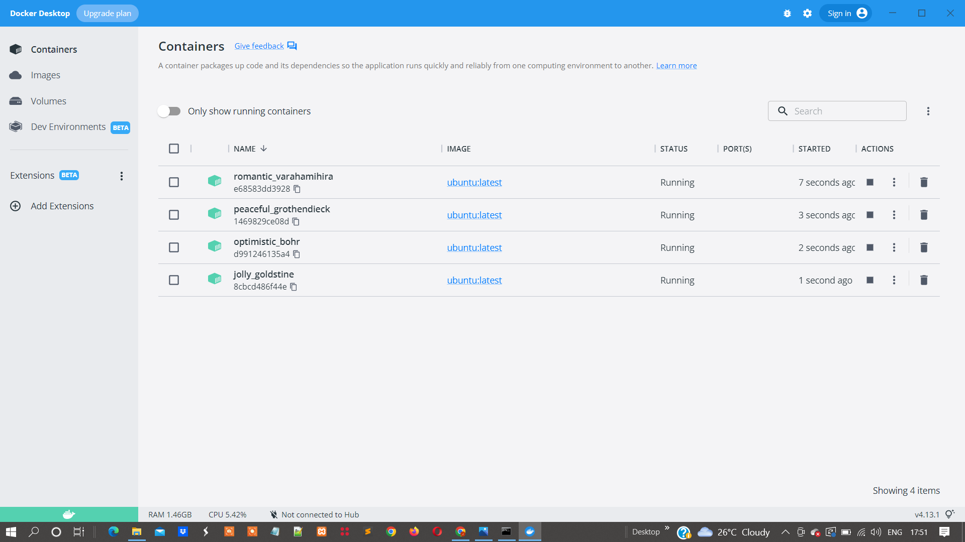Creating containers in Docker Desktop by using Command prompt by installing the OS.
2. Command Prompt for installing the OS and to check the versions of docker and to get help:

